***SYNOPSIS***

**Report on**

**Online Auction System**

**by**

Ekansh Srivastava (2200290140059)

Akash Singh (2200290140019)

**Session: 2023-2024 (III Semester)**

Under the supervision of

**Prof. (Dr.) / Dr. / M/S SHALIKA ARORA (asst. Professor)**

### KIET Group of Institutions, Delhi-NCR, Ghaziabad



### Department Of Computer Applications

**KIET GROUP OF INSTITUTIONS, DELHI-NCR, GHAZIABAD-201206**

(2023 - 2024)

Abstract

The Online Auction System is a web-based platform designed to facilitate the buying and selling of various goods and services through a dynamic and transparent bidding mechanism. This digital marketplace harnesses modern technology to create a secure and user-friendly environment, enhancing the auction experience for participants. Key features include real-time bidding, comprehensive item listings, efficient payment processing, and robust user authentication mechanisms. This abstract offers a concise glimpse into the Online Auction System, emphasizing its vital role in the contemporary digital economy.

Keywords:

1. Online Auction System
2. E-commerce
3. Bidding
4. Digital Marketplace
5. User Authentication
6. Item Listings
7. Internet-based Auctions

Table of Contents

|  |  |
| --- | --- |
| 1. | Introduction |
| 2. | Project / Research Objective |
| 3. | Literature review |
| 4. | Project Flow/ Research Methodology |
| 5. | Project / Research Outcome |
| 6. | Proposed Time Duration |

Introduction

The advent of the internet has revolutionized the way commerce operates, and one of the most remarkable manifestations of this digital transformation is the Online Auction System. This innovative platform has fundamentally reshaped the buying and selling landscape, transcending geographical boundaries and creating a dynamic marketplace accessible to anyone with an internet connection.

At its core, the online auction system offers an unparalleled opportunity for individuals and businesses to engage in trade on a global scale. Whether you're a seller looking to showcase your products to a vast and diverse audience or a bidder searching for unique items or competitive deals, this system provides an inclusive and efficient environment for both parties.

In this interconnected world, the concept of "global reach" takes center stage. The online auction system empowers sellers to connect with potential customers from different corners of the world, offering their wares to a broader and more diverse market. Simultaneously, it enables bidders to explore a vast array of products and services, transcending the limitations of physical proximity.

Throughout this exploration, transparency and trust play pivotal roles. The system's architecture ensures that participants can view real-time bid updates, track auctions, and provide feedback, fostering an environment of integrity and accountability.

This introduction sets the stage for a comprehensive exploration of the online auction system, delving into its features, benefits, and impact on modern commerce. As technology continues to evolve, this system remains a dynamic force, shaping the future of e-commerce and opening new horizons for businesses and consumers alike.

Literature Review

Online auction systems have become a prominent platform for buying and selling goods and services in the digital age. These platforms have evolved significantly over the years, shaping the way people conduct transactions and interact in the virtual marketplace. This literature review provides an overview of key research findings, trends, and challenges in the field of online auctions.

1. Evolution of Online Auction Systems

The concept of online auctions can be traced back to the early days of the internet with platforms like eBay, which revolutionized the way people buy and sell items. Early research focused on understanding the adoption and diffusion of online auctions among users (Bakos & Brynjolfsson, 2000) and the role of trust in online auction transactions (Resnick & Zeckhauser, 2002).

2. Auction Mechanisms and Bidding Strategies

Research has extensively explored different auction mechanisms used in online platforms. Vickrey auctions (Vickrey, 1961) and English auctions (Klemperer, 1999) are among the most studied. Vickrey auctions, known for their incentive compatibility, have been analyzed for their efficiency in online contexts (Chen, 2007). The strategic behavior of bidders, including sniping and bidding strategies, has also been a subject of interest (Roth & Ockenfels, 2002).

3. Trust and Reputation Systems

Trust is a critical factor in online auctions, as buyers and sellers often transact with anonymous parties. Reputation systems play a significant role in establishing trust (Resnick & Zeckhauser, 2002). Researchers have examined the impact of reputation scores on bidding behavior (Dellarocas, 2006) and the design of effective reputation mechanisms (Dellarocas, 2003).

4. Dynamic Pricing and Auction Strategies

Dynamic pricing strategies have gained traction in online auctions, allowing sellers to optimize their revenue by adjusting prices in real-time. Research has explored dynamic reserve pricing (Bakos & Brynjolfsson, 2000) and the use of data-driven techniques for setting optimal prices (Lucking-Reiley et al., 2006). Additionally, auction platforms like eBay have implemented "Buy It Now" options, which have been investigated for their impact on auction dynamics (Lucking-Reiley, 2000).

6. Mobile and Social Auctions

With the proliferation of smartphones and social media, mobile and social auctions have gained popularity. Studies have explored the impact of mobile auction apps (Koufaris et al., 2012) and the role of social networks in facilitating online auctions (Zhu et al., 2013). These trends signify the importance of adapting online auction systems to evolving technology and user preferences.

8. Future Directions and Challenges

The field of online auctions continues to evolve, with emerging trends such as blockchain-based auctions and the integration of artificial intelligence for dynamic pricing. Challenges remain in addressing trust issues, preventing fraud, and ensuring ethical practices in the online auction ecosystem.

In conclusion, online auction systems have undergone significant development and have become a fundamental component of e-commerce. Research in this field has contributed valuable insights into auction mechanisms, trust-building strategies, pricing dynamics, and emerging trends. As online auctions continue to evolve, it is essential to adapt to the changing landscape and address the challenges to create a secure and efficient marketplace for buyers and sellers.

Top of Form

Purpose

The purpose of an online auction system is to provide a platform that facilitates the buying and selling of various products through an online bidding process. This system serves the needs of both sellers and bidders, creating a virtual marketplace where items are auctioned to the highest bidder. The key purposes of an online auction system include:

Efficient Buying and Selling: To offer a convenient and efficient way for individuals and businesses to sell their products to a wide audience and for buyers to acquire desired items.

Price Discovery: To enable sellers to discover the market value of their products through competitive bidding, ensuring fair prices based on supply and demand.

Global Reach: To extend the reach of sellers beyond their local markets, connecting them with potential buyers from around the world.

Convenience: To provide a convenient and accessible platform where users can participate in auctions from the comfort of their homes or offices, eliminating geographical constraints.

Transparency: To maintain transparency in the bidding process, allowing users to see the current highest bid and the remaining time for bidding.

Feedback Mechanism: To collect and display user feedback, promoting trust and accountability among participants.

Solution

To achieve these purposes, an effective online auction system must offer a comprehensive solution that encompasses various features and functionalities. Here's a breakdown of the solution:

User Registration and Authentication:

Users can register with their personal information, creating secure accounts with unique credentials.

Product Listing:

Sellers can create detailed product listings, including descriptions, images, categories, starting bid prices, and auction durations.

Auction Mechanism:

Implement a bidding system that allows users to place bids on products within specified auction timeframes.

Automatically close auctions when time elapses and declare the highest bidder as the winner.

User Roles:

Define roles such as Sellers, Bidders, and Admin for efficient platform management.

Admin Panel:

Admin can oversee and moderate the entire system, including user accounts and product listings.

Security and Privacy:

Implement robust security measures to protect user data and transactions, ensuring privacy and data integrity.

Objective of project

The objective of the online auction system project is to create a robust and user-friendly platform that enables users to buy and sell items through online auctions. This platform aims to

[1] Facilitate Online Auctions: Provide a digital marketplace where individuals and businesses can easily list items for auction and participate in bidding processes, eliminating geographical constraints.

[2] User-Friendly Interface: Develop an intuitive and user-friendly website/application interface that allows users to navigate auctions, place bids, and manage their auction-related activities with ease.

[3] Feedback and Rating System: The introduction of a feedback and rating system allows users to share their auction experiences, fostering transparency and trust.

[4] User Login: User can register online and then access the system on authentication.

[5] Sort Products: User can sort products by category and price range.

[6] Global Reach: To extend the reach of sellers beyond their local markets, connecting them with potential buyers from around the world.

Basics need of Hardware and Software

Software Requirements:

* + Operating System: windows 8 or Higher
  + Vs Code, Xampp Server

Hardware Components:

* + Processor – i3
  + Hard Disk – 500 GB
  + Memory – 8GB RAM

Block Diagram

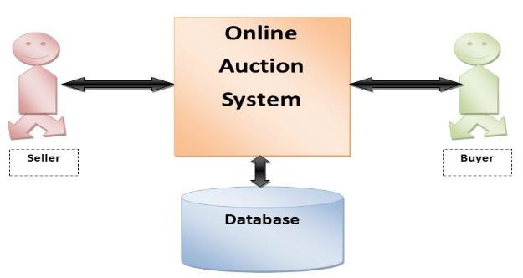

0 Level DFD

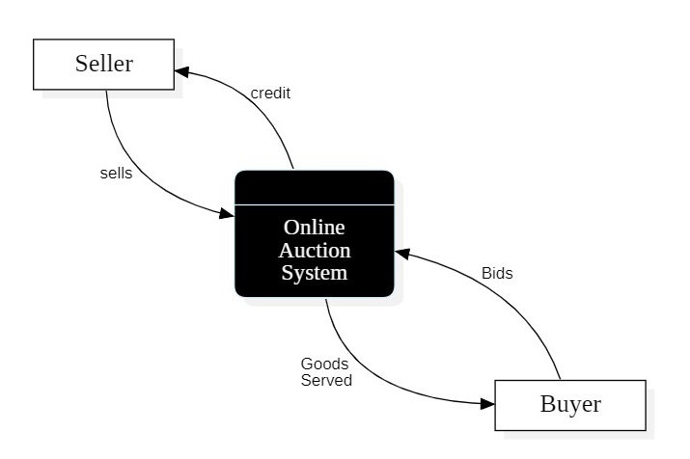

Conclusion

In conclusion, the online auction system represents a dynamic and transformative platform that has redefined the way people buy and sell products in the digital age. This innovative system has successfully addressed the challenges of traditional auctions, breaking down geographical constraints and ushering in a new era of global commerce.

One of its paramount achievements is its ability to provide a level playing field for sellers and buyers alike. Sellers can showcase their products to a vast and diverse global audience, reaching potential customers they could never have accessed through conventional means. The competitive bidding process ensures fair market prices, benefiting both sellers and buyers by facilitating price discovery.

Moreover, the online auction system fosters transparency and trust in transactions. Participants can view real-time bid updates and monitor auctions from the comfort of their homes or offices, enhancing convenience. The feedback mechanism further promotes accountability and builds a reputation system, assuring users of the platform's reliability.

Admin oversight, stringent security measures, and integrated payment solutions contribute to the system's robustness. It not only expands economic opportunities but also embraces the principles of accessibility, inclusivity, and convenience, making it a valuable asset in the digital economy.

As technology continues to evolve, the online auction system will likely play an increasingly pivotal role in shaping the future of e-commerce. Its ability to connect individuals and businesses worldwide while promoting fair competition and transparency positions it as a cornerstone of modern global trade.